# 1. INTRODUCTION

## **1.1 INTRODUCTION**

Lane line detection is critical for self-driving cars, ensuring they maintain their designated lanes and avoid accidents. The machine learning project will leverage the OpenCV library to achieve real-time lane line detection. Detection will involve identifying white lane markings on both sides of the lane, employing computer vision algorithms. Techniques such as image preprocessing, edge detection, and line detection algorithms will be utilized for accurate lane detection. Real-time processing capabilities will enable continuous monitoring and adjustment to changing road conditions, ensuring reliable performance in diverse environments.

## **1.2 PROBLEM STATEMENT**

The project aims to develop a robust and accurate road lane detection system essential for autonomous vehicles. Current lane detection methods struggle with challenges such as varying complex road scenarios, dynamic obstacles, and the need for real-time processing. This project will address these issues by designing and implementing an advanced methods capable of detecting lane markings reliably under diverse conditions. Using a combination of image processing techniques and machine learning, the algorithm will be optimized for real-time performance and tested against a comprehensive dataset. The goal is to enhance the system's accuracy and robustness, making it suitable for integration into autonomous driving systems, ultimately contributing to safer and more efficient self-driving technology.

## **1.3 OBJECTIVES**

The objectives of this project are:

* To gain a comprehensive understanding of OpenCV and its capabilities in image processing.
* To develop proficiency in image processing techniques, focusing on their application in road lane detection.
* To design and implement a robust algorithm using OpenCV that accurately detects lane lines under various conditions.
* To enhance the system's robustness, ensuring reliable performance in the presence of shadows, obstacles, and changes in the road environment.
* To implement classification of different lane types (e.g., left, right, dashed, solid) to aid in more nuanced lane detection.
* To integrate the lane detection system with vehicle systems and provide detailed, user-friendly documentation to facilitate implementation and usage.

**1.4 LIMITATIONS**

* Focus on Straight Lanes: The majority of existing techniques are designed for straight lane detection, often ignoring curved lanes, which results in poor performance on roads with curves.
* Lack of Improvements in Hough Transform: Improvements and optimizations in the Hough Transform method have not been thoroughly explored, which could enhance lane detection accuracy.

**2.SYSTEM ANALYSIS**

**2.1 INTRODUCTION**

Lane detection is a crucial aspect of autonomous vehicles, driver assistance systems, and traffic monitoring systems. The ability to detect and track road lanes accurately is essential for safe and efficient navigation. In recent years, there has been significant progress in road and lane detection, with various techniques being proposed and implemented. In this project, we focus on developing a simple road lane detection system using OpenCV, a popular computer vision library. The system is designed to detect road lanes in pre-recorded videos or images, and does not require real-time processing. The system uses a combination of image processing techniques, such as filtering, colour masking, edge detection, and Hough transforms, to detect road lanes.

**2.2 EXISTING SYSTEM**

In recent years, the development of various lane detection algorithms has significantly advanced the capabilities of Advanced Driver Assistance Systems (ADAS), which are crucial for improving driving safety and driver convenience. These algorithms primarily focus on detecting straight lanes, employing methods like the Hough Transform, Canny Edge Detection, and machine learning techniques to achieve high accuracy in well-structured road environments. These straight lane detection methods are relatively straightforward and computationally efficient, making them suitable for real-time applications in ADAS. However, the detection of curved lanes presents a more complex challenge. Curved lanes can vary significantly in shape, and their appearance can be influenced by various factors such as road geometry, vehicle speed, and environmental conditions like lighting and weather. Traditional lane detection algorithms often struggle with these complexities, leading to reduced accuracy and reliability in real-world driving scenarios where roads are rarely perfectly straight.

**2.3 DISADVANTAGES OF EXISTING SYSTEM**

* Focus on Straight Lanes: The majority of existing techniques are designed for straight lane detection, often ignoring curved lanes, which results in poor performance on roads with curves.
* Lack of Improvements in Hough Transform: Improvements and optimizations in the Hough Transform method have not been thoroughly explored, which could enhance lane detection accuracy.

To address these limitations, researchers are exploring advanced approaches that leverage deep learning and computer vision techniques. Convolutional Neural Networks (CNNs) and other deep learning architectures have shown promise in capturing the intricate features of curved lanes by learning from large datasets of diverse road images. These models can better handle the variability in lane shapes and environmental conditions, providing more robust lane detection capabilities.

Additionally, integrating temporal information through Recurrent Neural Networks (RNNs) or Long Short-Term Memory (LSTM) networks can enhance the prediction of lane trajectories over time, further improving the detection of both straight and curved lanes. By continuously updating the lane model based on the vehicle's movement and road context, these advanced systems aim to provide more reliable lane-keeping assistance and navigation support.

Overall, while significant progress has been made in straight lane detection, the effective detection of curved lanes remains a critical area of research. The ongoing development of sophisticated algorithms and the incorporation of machine learning techniques hold the potential to overcome these challenges, paving the way for more advanced and reliable ADAS functionalities.

**2.4 PROPOSED SYSTEM**

In the field of Advanced Driver Assistance Systems (ADAS), lane detection is crucial for safe navigation. However, current models primarily focus on straight lanes, neglecting the detection of curved lanes. Additionally, improvements in the Hough Transform for enhanced lane detection and the impact of unfavourable weather conditions like fog have been overlooked. To address these gaps, we propose a novel model using OpenCV for lane detection.

The proposed model aims to bridge the gaps in current lane detection systems by effectively handling both straight and curved lanes, improving accuracy with advanced Hough Transform techniques, and enhancing robustness against environmental conditions, all while maintaining real-time performance and scalability.

**2.5 ADVANTAGES OF EXISTING SYSTEM**

* Effective Detection of Both Straight and Curved Lanes: The proposed model uses advanced algorithms to accurately detect both straight and curved lanes, improving adaptability to various road types.
* Enhanced Hough Transform Techniques: By incorporating improved Hough Transform methods, the model increases the precision of lane detection, ensuring more reliable performance.

**3. SYSTEM STUDY**

## **3.1 FEASIBILITY STUDY**

The feasibility study indicates that implementing a simple road lane detection system using OpenCV is economically, technically, and operationally feasible. The use of open-source tools minimizes costs, the technical requirements are met by available technologies and expertise, and the system can be seamlessly integrated into existing operations. This project not only promises to be cost-effective and practical but also contributes significantly to improving road safety and efficiency. For feasibility analysis, some understanding of the major requirements for the system is essential.

Three key considerations involved in the feasibility analysis are:

* ECONOMICAL FEASIBILITY
* TECHNICAL FEASIBILITY
* OPERATIONAL FEASIBILITY

### **3.1.1 ECONOMICAL FEASIBILITY**

Economic feasibility indicates that implementing a simple road lane detection system using OpenCV is cost-effective. The development costs are minimal due to OpenCV being an open-source library with no licensing fees, and primary expenses limited to basic hardware and developer time. Deployment can be economical by leveraging existing infrastructure such as in-car cameras, negating the need for new hardware. Maintenance involves low ongoing costs for software updates and occasional recalibration, supported by a large community and extensive documentation. Overall, the economic feasibility is high due to the low costs associated with open-source tools and minimal additional hardware requirements.

**3.1.2 TECHNICAL FEASIBILITY**

Technical feasibility indicates that the necessary technology and expertise for implementing a simple road lane detection system using OpenCV are readily available and sufficient. OpenCV offers robust tools for essential tasks such as edge detection, image transformation, and feature extraction, and techniques like Canny edge detection and Hough Transform can be implemented on standard hardware. The system is scalable, capable of integrating with more powerful hardware or cloud-based services for enhanced performance. Basic knowledge of Python and computer vision principles is adequate for development, with ample online resources available to support learning. Thus, the technical feasibility is high due to the accessible technologies, tools, and low expertise requirements.

**3.1.3 OPERATIONAL FEASIBILITY**

Operational feasibility indicates that the proposed road lane detection system using OpenCV can be seamlessly integrated into existing road monitoring setups or vehicles with minimal disruption. The user interface can be designed to be user-friendly, requiring minimal training, and offering automated alerts and visual aids. With proper calibration and testing, the system can achieve high reliability and accuracy in various conditions, enhancing road safety by providing real-time lane detection and alerts. Regular maintenance involves manageable software updates and system checks, supported by the extensive OpenCV community. Overall, operational feasibility is high due to effective integration, enhanced safety, and efficient maintenance.

**4.SYSTEM REQUIREMENTS SPECIFICATIONS**

**4.1 REQUIREMENT ANALYSIS**

The objective of this project is to develop a simple road lane detection system using OpenCV to identify and highlight lane markings on road images or video streams in real-time. This system aims to enhance road safety by assisting drivers in maintaining lane discipline and is designed to operate reliably under various lighting and weather conditions. It will benefit drivers with real-time assistance, automobile manufacturers with enhanced safety features, traffic management authorities with better lane monitoring, and developers and researchers by providing a foundation for further innovation in lane detection algorithms.

**4.2 FUNCTIONAL REQUIREMENTS**

The functional requirements for the simple road lane detection system using OpenCV include handling input from various sources such as dash cameras and smartphones, and performing pre-processing steps like grayscale conversion and Gaussian Blur to simplify and smooth the image. The system will use Canny edge detection to identify edges and apply ROI masking to focus on the road. It will detect lines using the Hough Transform and overlay these detected lanes on the original image or video frame. The system must process frames in real-time, providing a visual display with highlighted lanes and issuing visual or auditory alerts if the vehicle deviates from the lane.

**4.3 NON-FUNCTIONAL REQUIREMENTS**

The non-functional requirements for the simple road lane detection system using OpenCV emphasize performance, usability, reliability, maintainability, scalability, security, and portability. The system must process video frames in with minimal latency and operate efficiently on standard hardware. It should feature an intuitive user interface and be compatible with various input sources. High accuracy and robustness in lane detection across different conditions are essential. The system should have a modular design for easy maintenance and comprehensive documentation. Scalability is required to handle increased performance demands, while data privacy and access control measures must be implemented to ensure security. Additionally, the system should be platform-independent, capable of running on Windows, macOS, and Linux.

## **4.4 INPUT DESIGN AND OUTPUT DESIGN**

**4.4.1 INPUT DESIGN**

The input to the system is pre-recorded videos or images that capture the road lane. The input design is crucial in ensuring that the system receives high-quality data that can be accurately processed. The input data should be clear, concise, and relevant to the road lane detection task. The input design for the road lane detection system should consider high-resolution and high-quality images, clear of noise and distortion, and captured with calibrated cameras for accuracy and consistency. The input data must be in a compatible format for the system's software and hardware. Measures to ensure high-quality input data include preprocessing to remove noise and correct distortions, validating data to meet required standards, and normalizing data for consistency. These steps ensure that the system can accurately detect road lanes and provide reliable output.

#### **4.4.1.1 OBJECTIVES**

#### The objectives of input design aim to ensure a clear and accurate representation of road lanes for effective processing within the system. This involves employing high-quality cameras or sensors to capture detailed images, converting data into suitable digital formats, and ensuring compatibility with system software and hardware. Key considerations include high image resolution to capture lane details, maintaining image clarity and minimizing distortion, and proper calibration of cameras or sensors for accuracy and consistency. Overall, the focus is on facilitating seamless data processing to enhance the system's ability to interpret road lane information effectively.

### **4.4.2 OUTPUT DESIGN**

The output of the system is the detected road lanes, which can be represented in various formats, such as images, videos, or data files. The output design is crucial in ensuring that the system provides accurate and reliable results that can be used for further processing or analysis.

#### **4.4.2.1 OBJECTIVES**

The output design for the road lane detection system aims to accurately represent detected road lanes and ensure compatibility for seamless integration with other systems like autonomous vehicles or traffic monitoring systems. It prioritizes output formats that encompass images, videos, data files, or graphical user interfaces, facilitating further processing or analysis. Key considerations include maintaining accuracy in depicting lane attributes, ensuring visual appeal and clarity for easy comprehension, and secure, efficient data storage for accessibility in subsequent analysis. These objectives collectively enhance the system's utility and usability in providing reliable information about detected road lanes for various applications.

## **4.5 SYSTEM REQUIREMENTS**

### **4.5.1 SOFTWAREREQUIREMENTS**

* Operating System: Windows 11.
* Coding Language: Python.
* Text editors: vscode/pycharm/eclipse

**4.5.2 HARDWARE REQUIREMENTS**

* Processor - i5 or above
* RAM - 4 GB (min)
* Hard Disk - 512 GB
* Key - Standard Windows Keyboard
* Mouse - Two or Three Button Mouse

**5. SYSTEM DESIGN**

**5.1 SYSTEM DESIGN:**

The purpose of this system design is to outline the architecture and functionality of a simple road lane detection system using OpenCV. This system aims to detect and represent road lanes from input images or video streams, serving as a fundamental component for various applications such as autonomous driving, traffic monitoring, and lane departure warning systems. The road lane detection system comprises several interconnected modules designed to process input data, detect road lanes, and generate appropriate output representations. The key components include:

* Input Module: Responsible for acquiring input data, which can be images or video frames captured by a camera mounted on a vehicle or a stationary camera.
* Preprocessing Module: Handles preprocessing tasks such as image resizing, colour space conversion, noise reduction, and edge detection to prepare the input data for lane detection.
* Lane Detection Module: Implements algorithms for detecting road lanes from pre-processed images using techniques like Hough transform or polynomial curve fitting.
* Output Module: Generates output representations of detected road lanes, which may include annotated images, video streams with overlayed lanes, or data files containing lane parameters.
* Visualization Module: Provides a graphical user interface (GUI) for real-time visualization of detected lanes and system parameters, facilitating user interaction and system monitoring.

The designed road lane detection system using OpenCV offers a comprehensive solution for accurately detecting road lanes from input images or video streams. By integrating various modules for input processing, lane detection, and output representation, the system can be applied to different scenarios with flexibility and reliability. Further optimizations and enhancements can be explored to improve system performance and robustness in real-world applications.

* **Detailed System Design:**
* **Input Module:**
* Utilizes OpenCV's Video Capture module to read video frames from a camera or input video file.
* Converts input frames to the appropriate colour space (e.g., RGB to grayscale) for further processing.
* **Preprocessing Module:**
* Applies Gaussian blurring to reduce noise and smoothen images.
* Utilizes Canny edge detection to extract edges from pre-processed images.
* **Lane Detection Module:**
* Implements Hough transform algorithm to detect straight lines representing road lanes in the edge-detected image.
* Utilizes region of interest (ROI) masking to focus lane detection on relevant areas of the image.
* **Output Module:**
* Draws detected lane lines onto original input frames to create annotated images.
* Generates video streams with overlayed lane lines for visual representation.

**5.2 SYSTEM ARCHITECTURE**

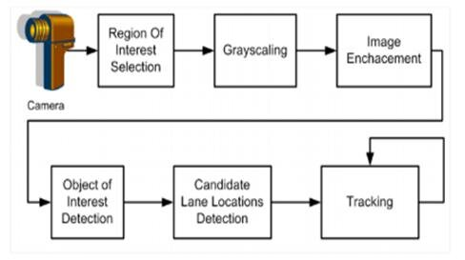

**FIG 5.1 ARCHITECTURE FOR ROAD LANE DETECTION**

The project flow will have the following activities:

* Input Image: The process begins with an input image.
* Check if Image is Coloured: Determine whether the input image is coloured.
* Convert to Gray: If the image is coloured, convert it to grayscale.
* Apply Filtering: Apply filtering techniques to the grayscale image to remove noise and smoothen the image.
* Apply Canny Edge Detector: Use the Canny edge detection algorithm to detect edges in the filtered grayscale image.
* Apply Hough Transform: Apply the Hough Transform technique to detect lines in the image from the edges identified.
* Detect and Colour Lanes: Detect the lanes based on the lines identified by the Hough Transform and colour them for visual representation.

## **5.3 UNIFIED MODELING LANGUAGE (UML)**

UML (Unified Modelling Language) diagrams are a standardized way to visualize and describe the design of a system. They provide a graphical representation of the system's components, relationships, and behaviour. In this section, we will elaborate on the UML diagrams used to design the road lane detection system.

**GOALS OF UML:**

The Primary goals in the design of the UML are as follows:

1. Provide users a ready-to-use, expressive visual modelling Language so that they can develop and exchange meaningful models.
2. Provide extensibility and specialization mechanisms to extend the core concepts.
3. Be independent of particular programming languages and development process.
4. Provide a formal basis for understanding the modelling language.

**5.3.1 USE CASE DIAGRAM**

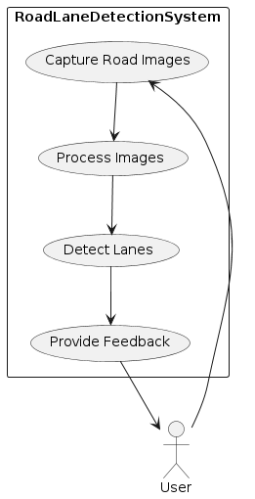

**FIG 5.3.1**

The provided use case diagram outlines a systematic approach for a road lane detection system. It begins with an input image, which is then assessed to determine if it is coloured or grayscale. If coloured, the image undergoes conversion to grayscale for further processing. Next, the grayscale image is subjected to filtering techniques to eliminate noise, followed by the application of the Canny edge detection algorithm to identify edges. Subsequently, the Hough Transform technique is employed to detect lines from the edges detected earlier. Finally, based on these identified lines, the system detects and colours the lanes for visual representation. This sequential flow ensures that each step contributes to the accurate detection and representation of road lanes, thereby enhancing the system's effectiveness in assisting drivers and analysing road conditions.

### **5.3.2 CLASS DIAGRAM**

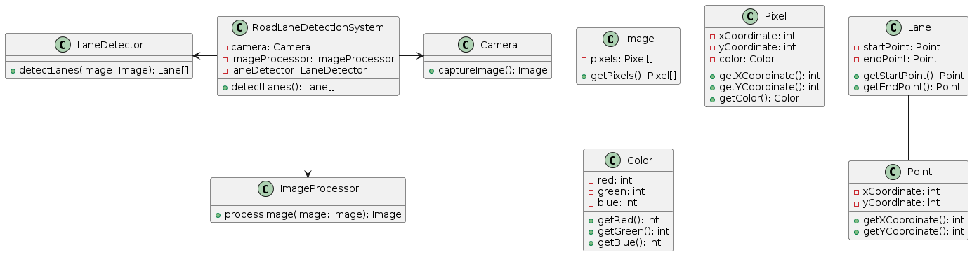

**FIG 5.3.2**

The class diagram illustrates a simplified model of a road lane detection system, a crucial component of autonomous vehicles and driver assistance systems. At the heart of the system lies the `RoadLaneDetectionSystem`, coordinating three main components: the `Camera`, responsible for capturing images of the road environment; the `ImageProcessor`, which analyses captured images to enhance quality and extract relevant features; and the `LaneDetector`, tasked with identifying lane markings from processed images. The `Image` class encapsulates pixel data, while `Pixel` represents individual image pixels with their coordinates and colour information. `Colour` further specifies the RGB components of each pixel. Detected lanes are represented by the `Lane` class, defined by their start and end points, which are instances of the `Point` class containing x and y coordinates. This diagram demonstrates the flow of data and processing steps involved in identifying road lanes, facilitating safer and more accurate navigation for vehicles.

**5.3.3 SEQUENCE DIAGRAM**

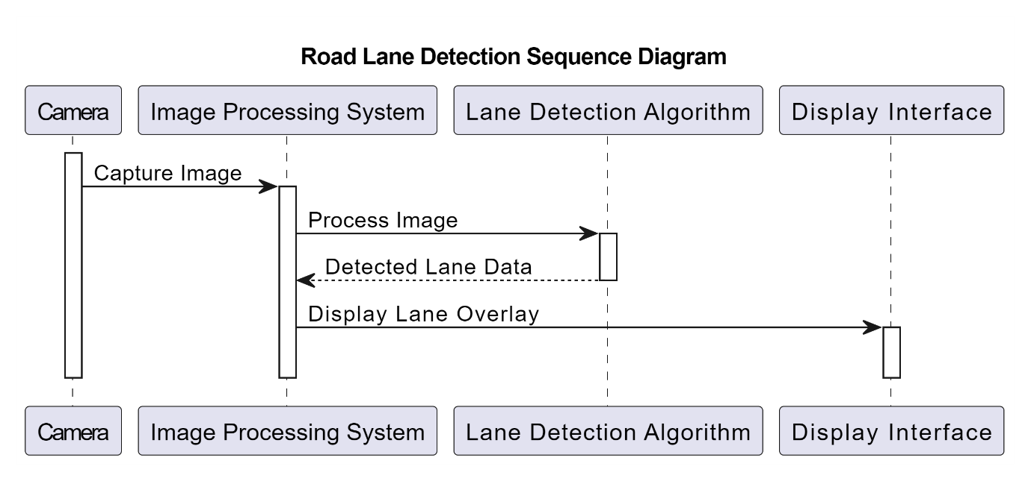

**FIG 5.3.3**

The sequence diagram illustrates the workflow of a road lane detection system. It begins with the camera capturing an image of the road, which is then processed by the image processing system. The processed image is forwarded to the lane detection algorithm, where the algorithm identifies the lane boundaries. Once the lanes are detected, the information is sent back to the image processing system, which overlays the detected lanes onto the original image. Finally, the processed image, now with lane overlays, is displayed on the interface for visualization. This sequence demonstrates the step-by-step process of how an image captured by a camera undergoes analysis and enhancement to highlight road lanes for better visibility and navigation assistance.

**5.3.4 DATA FLOW DIAGRAM**

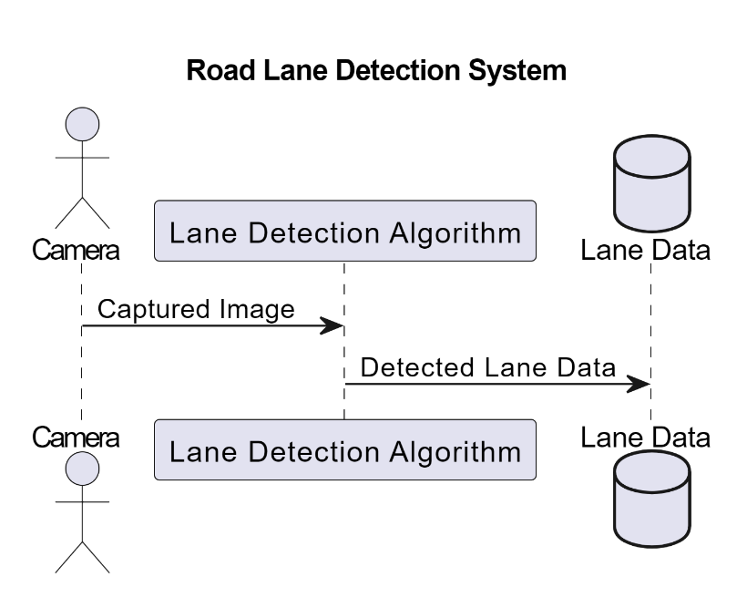

**FIG 5.3.4**

The data flow diagram illustrates a basic system for road lane detection. In this setup, a camera serves as the input device, capturing images of the road. These images are then processed by a lane detection algorithm, depicted as the intermediary component. Upon analysis, the algorithm extracts lane data from the captured images, identifying lane boundaries and markings. Finally, the detected lane data is stored in a database for further utilization or analysis. This system aims to facilitate the automatic identification and tracking of lanes on roads, a critical component in various applications such as autonomous driving systems, traffic monitoring, and road safety management.

**5.3.5 FLOW CHART DIAGRAM**

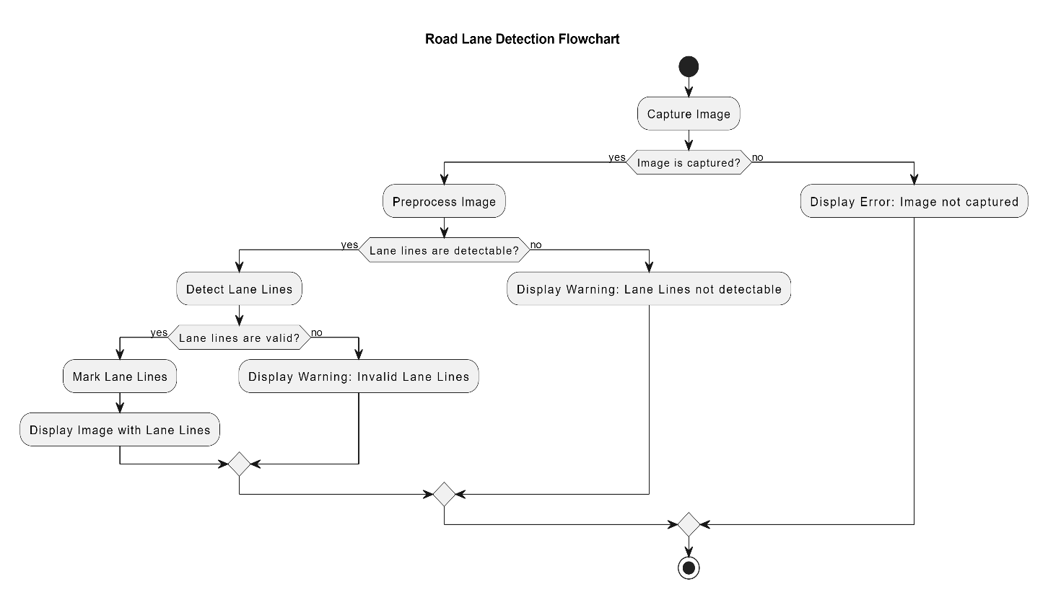

**FIG 5.3.5**

The provided flowchart illustrates the sequential steps involved in a simple road lane detection process. It begins by capturing an image of the road environment. Once the image is captured, it undergoes preprocessing to enhance its quality and prepare it for analysis. The system then attempts to detect lane lines within the pre-processed image. If lane lines are successfully detected, the system proceeds to verify their validity, ensuring they accurately represent the lanes on the road. Valid lane lines are then marked on the image, and the final result, displaying the marked lane lines, is presented. However, if lane lines cannot be detected or are deemed invalid, appropriate warnings are displayed to alert the user. This flowchart serves as a visual guide for understanding the logical flow of operations within the road lane detection algorithm.

**6.IMPLEMENTATION**

## **6.1 IMPLEMENTATION**

The goal of implementation is to make a code which is easy to read and understand. This is most vital stage in acquiring fruitful or a framework and giving the client certainly that the new programming or the framework is functionalist venues. The source code must be clear such that the debugging testing, modification can easily be done.

**6.2 MODULES**

We can consider each of these functions as modules or components:

* canny: Performs Canny edge detection on an input image.
* region_of_interest: Masks out a region of interest in the image.
* houghLines: Detects lines in the input image using the Hough transform.
* addWeighted: Combines the input image with the detected lines.
* display_lines: Draws detected lines on a black image.
* make_points: Calculates endpoints of lines based on slope and intercept.
* average_slope_intercept: Averages the slope and intercept of detected lines to get a single left and right line.

**SERVICE PROVIDER**

The service provider here would be the class or function responsible for handling the video capture and processing. In our code, it's the part where the video is captured frame by frame, processed, and displayed. So, in this case, the cap = cv2.VideoCapture("straight.mp4") line and the subsequent loop where the frame processing happens serve as the service provider.

**VIEW & AUTHORIZE USERS**

View: In our context, the "view" can be considered as the part of the code responsible for displaying the processed images to the user. This is mainly done through OpenCV functions like cv2.imshow().

**Authorized User:** In our code, there's no explicit concept of an authorized user. However, if you want to incorporate user authentication or permission checks, you would typically do that before allowing access to the video or the processing functionality. For instance, you might have a function or module responsible for user authentication, ensuring that only authorized users can access the video processing service.

**REMOTE USER**

**Remote User**: The "remote user" can refer to any user who is accessing the video processing service from a location different from where the code is running. Since this code doesn't involve network communication or remote access explicitly, every user accessing this service would need to run the code locally on their machine or within their environment.

**6.3 SOURCE CODE**

import cv2

import numpy as np

def canny(img):

if img is None:

cap.release()

cv2.destroyAllWindows()

exit()

gray = cv2.cvtColor(img, cv2.COLOR_BGR2GRAY)

kernel = 5

blur = cv2.GaussianBlur(gray, (kernel, kernel), 0)

canny = cv2.Canny(blur, 50, 150)

return canny

def region_of_interest(canny):

height = canny.shape[0]

width = canny.shape[1]

mask = np.zeros_like(canny)

triangle = np.array([[

(200, height),

(800, 350),

(1200, height),]], np.int32)

cv2.fillPoly(mask, [triangle], 255)

masked_image = cv2.bitwise_and(canny, mask)

return masked_image

def houghLines(cropped_canny):

return cv2.HoughLinesP(cropped_canny, 2, np.pi / 180, 100,

np.array([]), minLineLength=40, maxLineGap=5)

def addWeighted(frame, line_image):

return cv2.addWeighted(frame, 0.8, line_image, 1, 1)

def display_lines(img, lines):

line_image = np.zeros_like(img)

if lines is not None:

for line in lines:

for x1, y1, x2, y2 in line:

cv2.line(line_image, (x1, y1), (x2, y2), (0, 0, 255), 10)

return line_image

def make_points(image, line):

slope, intercept = line

y1 = int(image.shape[0])

y2 = int(y1 * 3.0 / 5)

x1 = int((y1 - intercept) / slope)

x2 = int((y2 - intercept) / slope)

return [[x1, y1, x2, y2]]

def average_slope_intercept(image, lines):

left_fit = []

right_fit = []

if lines is None:

return None

for line in lines:

for x1, y1, x2, y2 in line:

fit = np.polyfit((x1, x2), (y1, y2), 1)

slope = fit[0]

intercept = fit[1]

if slope < 0:

left_fit.append((slope, intercept))

else:

right_fit.append((slope, intercept))

left_fit_average = np.average(left_fit, axis=0) if left_fit else None

right_fit_average = np.average(right_fit, axis=0) if right_fit else None

left_line = make_points(image, left_fit_average) if left_fit_average is not None else None

right_line = make_points(image, right_fit_average) if right_fit_average is not None else None

averaged_lines = []

if left_line is not None:

averaged_lines.append(left_line)

if right_line is not None:

averaged_lines.append(right_line)

return averaged_lines

cap = cv2.VideoCapture("straight.mp4")

while(cap.isOpened()):

_, frame = cap.read()

canny_image = canny(frame)

cropped_canny = region_of_interest(canny_image)

lines = houghLines(cropped_canny)

averaged_lines = average_slope_intercept(frame, lines)

line_image = display_lines(frame, averaged_lines)

combo_image = addWeighted(frame, line_image)

cv2.imshow("result", combo_image)

if cv2.waitKey(1) & 0xFF == ord('q'):

break

cap.release()

cv2.destroyAllWindows()

**7.SCREENSHOTS**

**7.1 IMAGE PROCESSING**

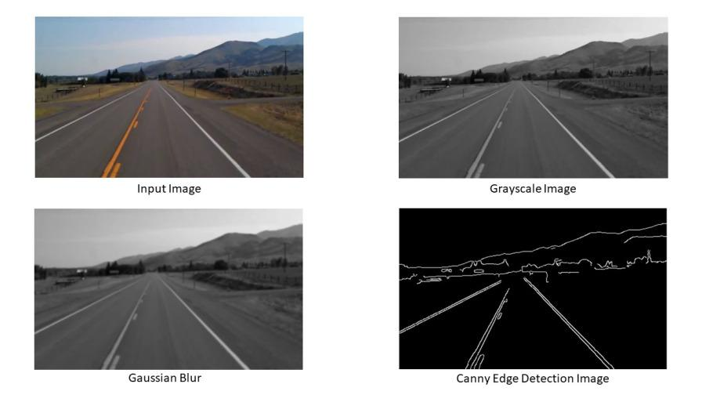

**Screenshot 7.1: Image processing**

**7.2 REGION OF INTEREST**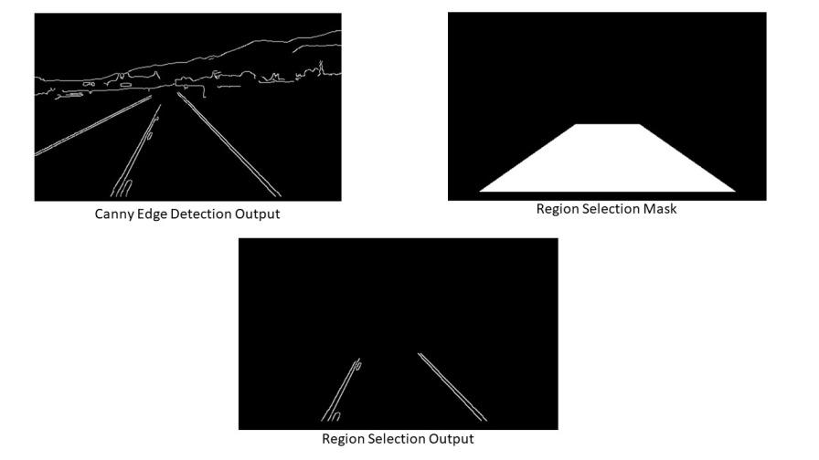

**Screenshot 7.2: Region selection**

**7.3 OUTPUT**

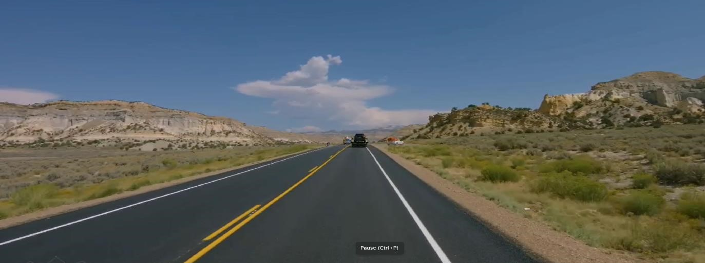

**Screenshot 7.3.1: Input Image**

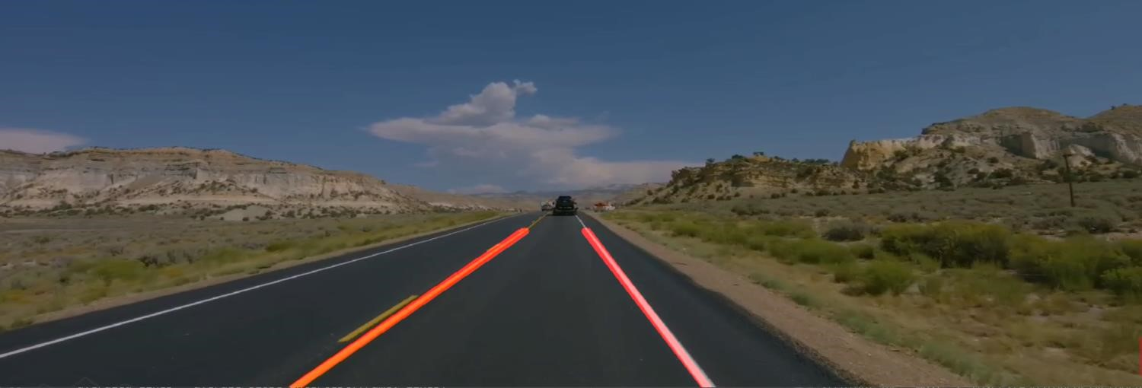

**Screenshot 7.3.2: Output Image**

**8. SYSTEM TESTING**

**8.1 UNIT TESTING:**

Unit testing focuses on verifying the correctness of individual components of the system. In the context of the road lane detection system, unit tests are designed to validate the functionality of core modules, such as edge detection, region of interest (ROI) selection, Hough Transform for line detection, and image preprocessing functions. Each of these components is tested independently to ensure they produce the correct output given a set of inputs. For example, the edge detection module might be tested with various images to ensure it consistently detects edges correctly. These tests help identify and fix bugs at an early stage, ensuring that each component works as intended before they are integrated into the larger system.

**8.2 FUNCTIONAL TESTING:**

Functional testing evaluates the system's compliance with specified requirements and ensures that it performs all its intended functions. For the road lane detection system, functional testing involves verifying that the system can accurately detect and highlight road lanes under different conditions and road types. This type of testing ensures that each function within the software application operates in conformance with the requirement specification. Tests are conducted using a variety of road images and video sequences to validate that the system can reliably identify lanes and provide the correct output, such as overlaying detected lanes on the original images or video frames.

**8.3 SYSTEM TESTING:**

System testing is the process of testing the complete, integrated system to evaluate the system's compliance with its specified requirements. It involves testing the entire road lane detection application as a whole, including all integrated components and external interfaces. The goal is to ensure that the system functions correctly in a complete and realistic environment. This testing phase assesses the system's performance, security, and overall behaviour under real-world conditions. It involves running the application with a range of inputs and verifying that the outputs are accurate and consistent. This phase is crucial for identifying issues that may not have been apparent during unit or functional testing.

**8.4 INTEGRATION TESTING:**

Integration testing focuses on the interactions between integrated units/modules to ensure they work together as expected. In the context of the road lane detection system, integration testing involves combining various modules, such as image preprocessing, edge detection, and lane line detection, and verifying that they work cohesively. This type of testing helps identify issues related to the interactions between different parts of the system, such as data passing and timing issues. For example, the integration between the edge detection module and the line detection module must be seamless to ensure that the detected edges are accurately processed for lane detection. Any discrepancies at this stage can be addressed before proceeding to system-wide testing.

**8.5 ACCEPTANCE TESTING:**

Acceptance testing is the final phase of testing, performed to determine whether the system meets the acceptance criteria and is ready for deployment. This testing phase involves validating the road lane detection system against the requirements and specifications provided by the stakeholders. It typically involves running the system in a real-world environment to ensure it performs effectively and efficiently in actual use cases. The tests are conducted using real-world driving videos and images to verify that the system can reliably detect road lanes under various conditions. Successful acceptance testing provides confidence that the system is ready for deployment and can be used by end-users with assurance of its accuracy and reliability.

# 9. CONCLUSION AND FUTURE ENHANCEMENT

**9.1 CONCLUSION:**

The Road Lane Detection project using OpenCV has been an extensive and enlightening endeavour, encompassing various stages of development and testing to ensure the creation of a robust and reliable system. Throughout the project, we have leveraged the powerful image processing capabilities of OpenCV to develop a system capable of accurately detecting road lanes in real-time, a fundamental component of advanced driver-assistance systems (ADAS).

The initial stages of the project involved understanding the problem domain and defining the system requirements. We explored the principles of image processing, edge detection, and Hough Transform, which are essential for effective lane detection. The implementation phase focused on developing core modules, including image preprocessing, edge detection, region of interest selection, and line detection. Each module was meticulously tested through unit testing to ensure its functionality and correctness.

In conclusion, the Road Lane Detection system developed using OpenCV is a testament to the effectiveness of combining theoretical knowledge with practical application. The project not only demonstrates the feasibility of implementing lane detection systems using open-source tools but also provides a solid foundation for future enhancements and integration with more advanced ADAS technologies. This project has equipped us with valuable insights and skills in image processing, system testing, and software development, laying the groundwork for further exploration and innovation in the field of autonomous driving and intelligent transportation systems.

**9.2 FUTURE ENHANCEMENT:**

Looking ahead, the road lane line detection project has room for growth. It could learn from real world situations better by using smart computer programs. Also, it could get better at understanding different types of road markings. Adjusting its settings in real-time could help it work well in changing conditions, including drastic weather conditions like fog and rainy roads. Combining information from different sensors could make it understand the road better. Making it easier for people to see and understand its findings could be helpful. Helping cars adjust their speed and direction based on what it sees could make driving safer. Sharing information with other cars could make it even smarter. By working on these improvements, the project can help make roads safer and driving easier for everyone.

# 10.BIBIOGRAPHY

## **10.1 REFERENCE**

1. Shopa, P., N. Sumetha and P.S.K Pathra. “Traffic sign detection and recognition using OpenCV",

International Conference on Information Communication and Embedded Systems

(ICICES2014), 2014

2. “Segnet: A deep convolutional encoder-decoder architecture for robust semantic pixelwise

labelling,” arXiv preprint arXiv:1505.07293, 2015.

3. J. Long, E. Shelhamer, and T. Darrell, “LANE DETECTION TECHNIQUES” – A Review.” in

Proceedings of the IEEE Conference on Computer Vision and Pattern Recognition, 2015, pp.

3431–3440.

4. M.Cordts,M. Omran,S.Ramos, T.Rehfeld,M. Enzweiler, R.Benenson,U. Franke,S.Roth, and

B.Schiele, “The cityscapes dataset for semantic urban scene understanding,” in Proc. of the

IEEE Conference on Computer Vision and Pattern Recognition (CVPR), 2016.

5. S. Zheng, S. Jayasumana, B. Romera-Paredes, V. Vineet, Z. Su, D. Du, C. Huang, And P.H Torr,

“A Layered Approach To Robust Lane Detection At Night.” 2015, pp. 1529–1537.